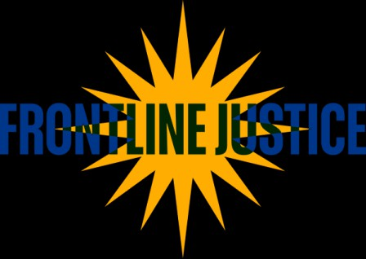

EJC Community Justice Worker Convening Call for Proposals

About the Session Proposal Form
Frontline Justice will host a community justice workers pre-conference on May 11, from 9:30 am to 4:30 pm. This pre-conference will take place at the Equal Justice Conference hotel in Charlotte, NC. The convening will provide the opportunity for shared learning, meaningful exchanges, and to hear firsthand from those on the frontlines who are providing this important help.

Space is limited to 100 participants.

This gathering is ideal for the following:

- Community justice workers
- Staff in legal aid organizations and medical-legal partnerships
- Staff and leaders in community-based organizations (e.g., United Way, Goodwill, AARP, neighborhood nonprofits)
- Benefits navigators, housing counselors, case managers, workforce, and social service staff
- Promotoras, peer specialists, lay advocates, and other trusted navigators

Please use this form to submit a session proposal for the convening. Feel free to share it with others you think would be a great addition to the agenda.

Note: EJC registration is separate from the pre-conference event and speaker conference registration, lodging, and travel costs are not covered by Frontline Justice.

Section 1: Presenter Information

- First Name of Primary Presenter * Last Name of Primary Presenter

- Email Address of Primary Presenter

- Organization/Affiliation

- Your Role

Are you submitting as an individual or with co-presenters?





Individual with 1 co-presenter with 2 co-presenters

 with 2 co-presenters and a moderator
Not sure yet

- Co-Presenter 1 First Name * Co-Presenter 1 Last Name
- Co-Presenter 1 Company * Co-Presenter 1 Email

- Co-Presenter 2 First Name * Co-Presenter 2 Last Name
- Co-Presenter 2 Company * Co-Presenter 2 Email

- Moderator First Name * Moderator Last Name
- Moderator Company * Moderator Email

Section 2: Session Details

- Proposed Session Title

- Session Description (150-250 words)
Prompt: What is your session about? What will participants learn or take away? Please focus on practice, storytelling, strategies, or insights from your work.

- ​
Does your proposal center on lived experience, community experience, or peer-led
practice?

 Yes  Somewhat  No Optional: Please explain how.

- ​
Preferred Session Format
 Facilitated discussion (45–
60 minutes)
 Panel discussion (45–60 minutes)

 Lightning talk (7–10 minutes)

Other (please describe)

 Case study or real-world example (45–60 minutes)
 Lecture or presentation (45–60 minutes)

 Hands-on or interactive activity (45–60 minutes)
 Demonstration of a tool, workflow, or practice (45–60 minutes)

- Which of the following best describe the focus and outcomes of your session? (Select all that apply)

 Practical tools or strategies participants can apply

Sustainability, wellness, or trauma-informed practices

Partnerships between community-based organizations, legal aid, or public agencies
Other (Please describe)
Lessons from programs, pilots, or on-the-ground practice
Training pathways, mentorship, or workforce development
Peer-to-peer learning or practice demonstrations

Policy or system insights relevant to justice worker programs

Section 3: Final Items

Is there anything else you'd like us to know about your proposed session or your work?

- If selected, I understand that sessions may be photographed or recorded and that presentation materials may be shared with conference participants
 Yes, I acknowledge and agree

- If selected, I confirm that I am available on May 11, 2026, and agree to meet present deadlines for session details and materials and to participate in reasonable planning communications.

Yes

